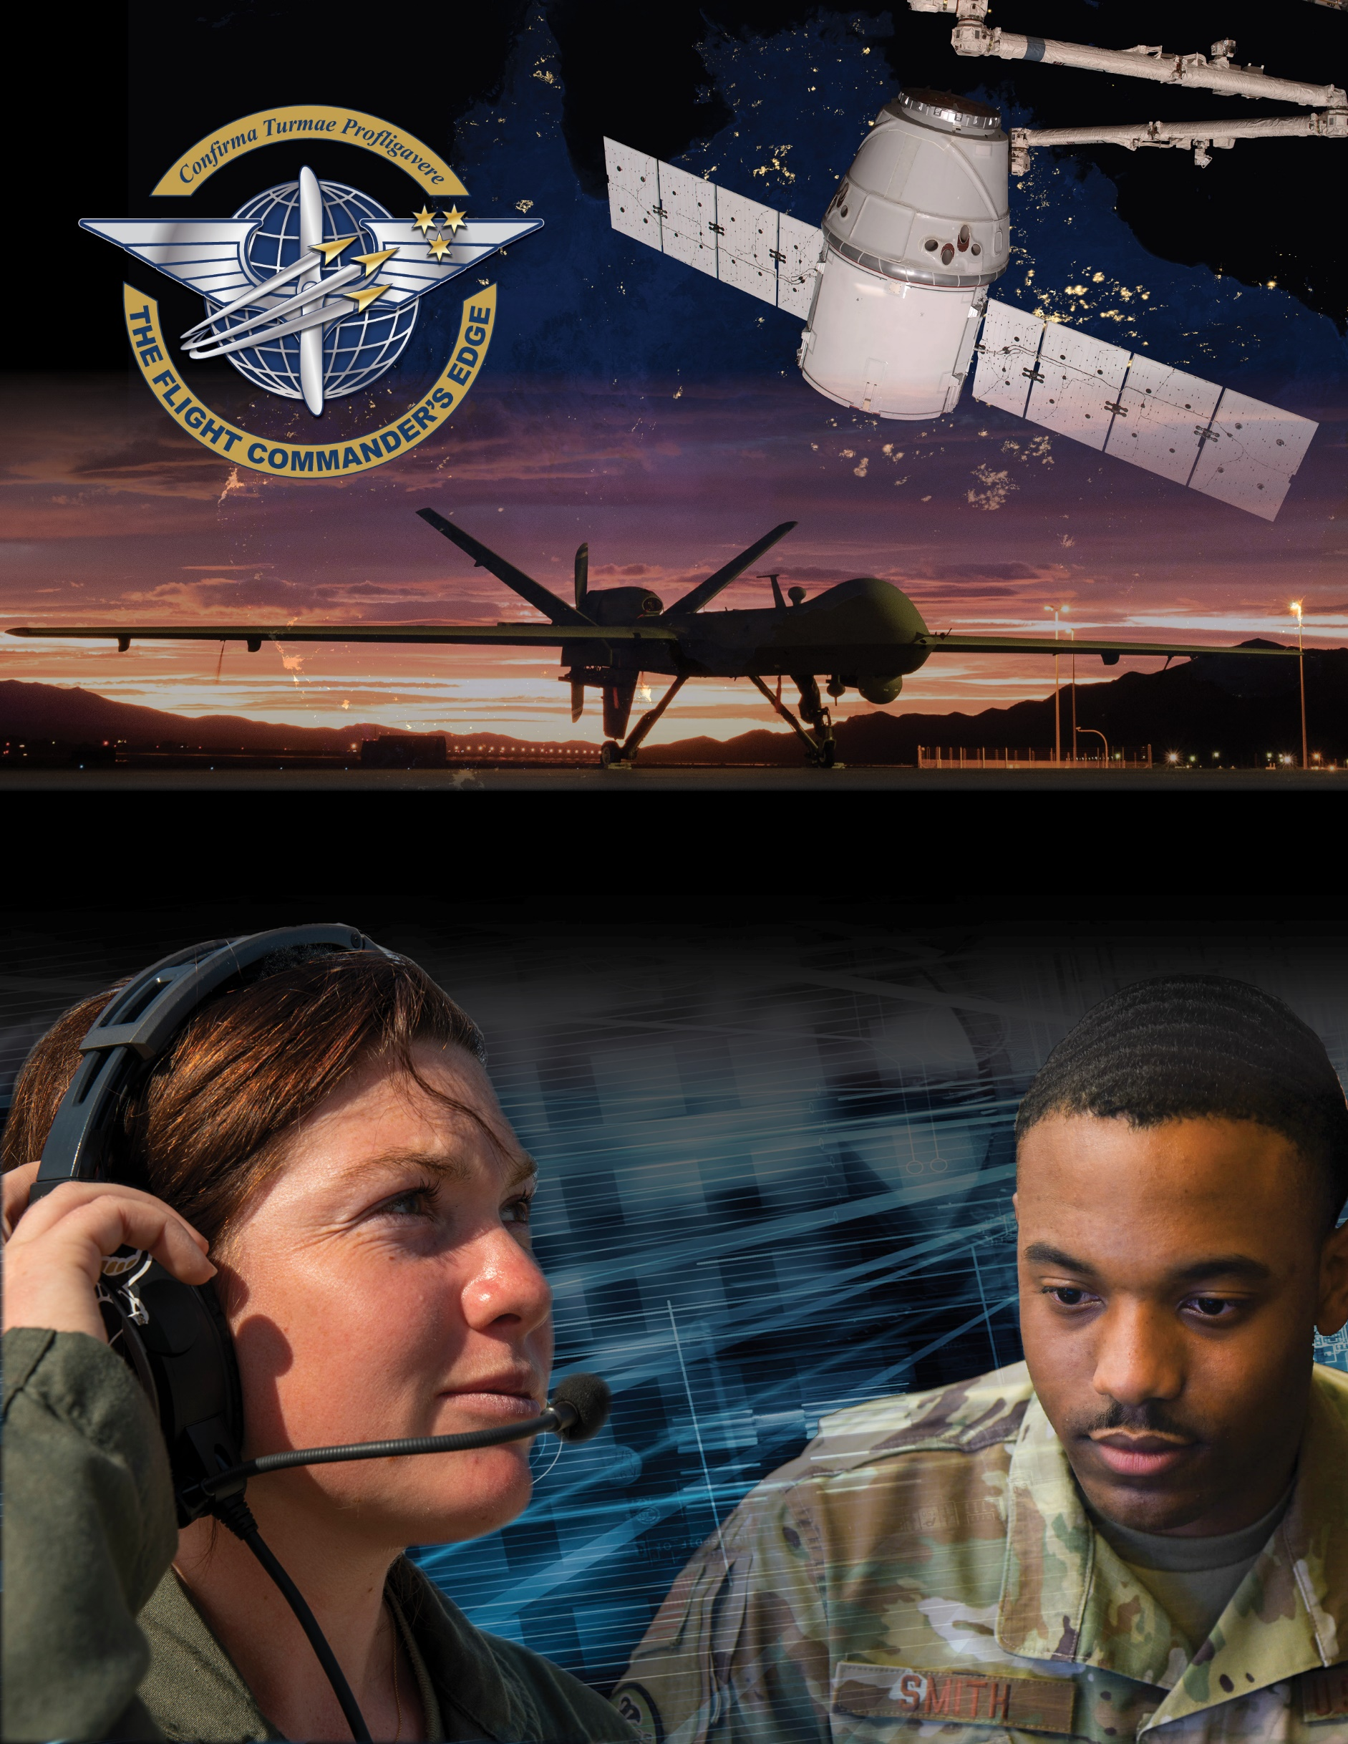

**Lesson Guide**



**Flight Commander Panel**

***14 April 2025***

**Flight Commander Panel**

### Purpose

This panel guide is designed to support the local development of Flight Commander Leadership Course materials. Selected facilitators should use this guide as they prepare presenters and panel topics. For more information on how lessons are structured, or how to use them in the course, see the ***Course Director’s Handbook*** or online Facilitator Resources.

### Scope

Leaders can learn a lot from the experiences and knowledge of others. This panel of experienced Flight Commanders has familiarity and insight into the position and how to navigate the role of leading a flight.

As a Flight Commander, you are charged with the responsibility of leading and developing others and ensuring the mission gets accomplished. There will be many challenges to overcome such as leading peers, leading NCOs (who may be older and more experienced than you) or making choices that will have cascading effects throughout the flight. By learning from the experiences of others you will be better suited to handle various situations as you execute the role of flight command.

### Recommended Objectives

By the end of this lesson, the participant should be able to:

1. Recognize how your perspective will change as you enter the role of Flight Commander.
2. Describe effective ways to leverage and support flight leadership and other SNCOs.
3. Apply lessons learned from experienced Flight Commanders to your respective situation.

### Recommended POC / Presenter

* Experienced or recently graduated flight commanders

### Recommended Length:

* 30 minutes (inclusive of questions)

### Recommended Approach

* Informal intro and background of each panel member followed by Q & A

**Potential Questions for the Panel to Address**

* How did you lean on, coordinate, or work with your Flt SNCOs?
* How did your mindset change as a Flight Commander versus before entering the role?
* What is something you are glad you did, or something you would like to have done, with/for the flight?
* How would you assess your tenure as a Flight Commander? What were your successes and/or failures?
* If you could pass on one lesson to an upcoming Flight Commander, what would it be?